
Institute of Education and Research
University of Peshawar
Time Allowed: 2 Hours
Timing: 9.00- 11.00 am
B.Ed. (Hons.) 8th Semester
Spring 2023

Final-Term Exam

Weekdays | Date | Timing | Subjects
Monday | 17-07- 2023 | 9.00- 11.00 am | School Management
Wednesday | 19-07- 2023 | 9.00- 11.00 am | Inclusive Education
Friday | 21-07- 2023 | 9.00- 11.00 am | Test Development and Evaluation

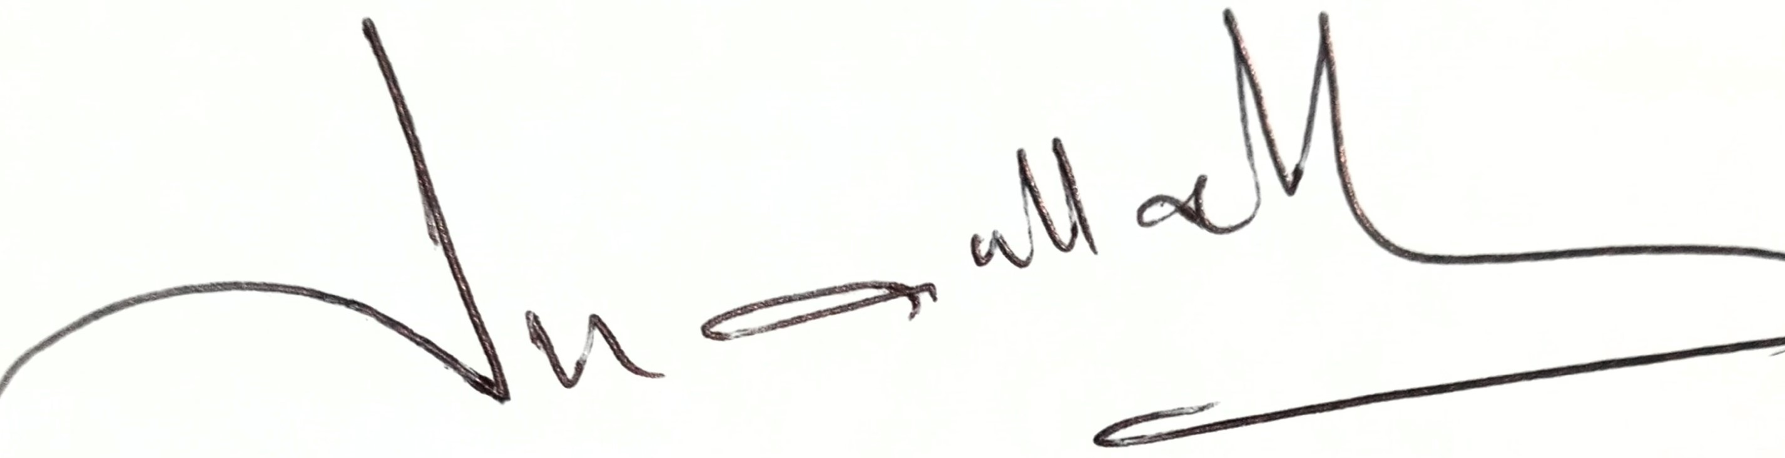
Director

Institute of Education and Research
University of Peshawar
Time Allowed: 2 Hours
Timing: 9.00- 11.00 am

B.Ed. (Hons.) 6th Semester
Spring 2023
Final-Term Exam

Weekdays | Date | Timing | Subjects
Monday | 17-07- 2023 | 9.00 – 11.00 am | Science
Tuesday | 18-07- 2023 | 9.00 – 11.00 am | Introduction to Guidance &counseling
Wednesday | 19-07- 2023 | 9.00 – 11.00 am | Urdu/Chemistry/Maths
Thursday | 20-07- 2023 | 9.00 – 11.00 am | English (Prose)/Bio/Physics
Friday | 21-07- 2023 | 9.00 – 11.00 am | Contemporary Issues and Trends in education
Monday | 24-07- 2023 | 9.00 – 11.00 am | Comparative Education

Director

Institute of Education and Research
University of Peshawar
Time Allowed: 2 Hours
Timing: 11.00 am - 1.00 pm
B.Ed. (Hons.) 4th Semester
Spring 2023
Final-Term Exam

Weekdays | Date | Timing | Subjects
Monday | 17-07- 2023 | 11.00 am – 1.00 pm | Classroom Assessment
Tuesday | 18-07- 2023 | 11.00 am – 1.00 pm | T. of. Mathematics
Wednesday | 19-07- 2023 | 11.00 am – 1.00 pm | Teaching of S. Studies
Thursday | 20-07- 2023 | 11.00 am – 1.00 pm | Teaching of English
Friday | 21-07- 2023 | 11.00 am – 1.00 pm | School Community & Teacher
Monday | 24-07- 2023 | 11.00 am – 1.00 pm | Portfolio Assessment

Director

Institute of Education and Research
University of Peshawar
Time Allowed: 2 Hours
Timing: 11.00 am - 1.00 pm
B.Ed. (Hons.) 2nd Semester
Spring 2023
Final-Term Exam

Weekdays | Date | Timing | Subjects
Monday | 17-07- 2023 | 11.00 am – 1.00 pm | Communication Skills
Tuesday | 18-07- 2023 | 11.00 am – 1.00 pm | Classroom Management
Wednesday | 19-07- 2023 | 11.00 am – 1.00 pm | Computer Literacy
Thursday | 20-07- 2023 | 11.00 am – 1.00 pm | General Mathematics
Friday | 21-07- 2023 | 11.00 am – 1.00 pm | Pakistan Studies
Monday | 24-07- 2023 | 11.00 am – 1.00 pm | Methods of Teaching Islamic Studies
Director

Institute of Education and Research
University of Peshawar
Time Allowed: 2 Hours
Timing: 9.00- 11.00 am
B.Ed. (1.5) 2nd Semester
Spring 2023

Final-Term Exam

Weekdays | Date | Timing | Subjects
Monday | 17-07- 2023 | 9.00- 11.00 am | Human Development and Learning
Tuesday | 18-07- 2023 | 9.00- 11.00 am | Educational Assessment
Wednesday | 19-07- 2023 | 9.00- 11.00 am | Method of Teaching:  Phy.Sc / English
Thursday | 20-07- 2023 | 9.00- 11.00 am | Method of Teaching:  Bio.Sc/Urdu/Maths

Director

Institute of Education and Research
University of Peshawar
Time Allowed: 2 Hours
Timing: 9.00- 11.00 am
BS (HPE) 4th semester
Spring 2023
Final-Term Exam
Weekdays | Date | Timing | Subjects
Monday | 17-07- 2023 | 9.00- 11.00 am | Exercise Physiology
Tuesday | 18-07- 2023 | 9.00- 11.00 am | Role of Media in Sports
Wednesday | 19-07- 2023 | 9.00- 11.00 am | Sports Nutrition
Thursday | 20-07- 2023 | 9.00- 11.00 am | Computer Skills
Friday | 21-07- 2023 | 9.00- 11.00 am | Pakistan Studies
Monday | 24-07- 2023 | 9.00- 11.00 am | Games/ Track and Field  / Gymnastic

Director
Institute of Education and Research
University of Peshawar
Time Allowed: 2 Hours
Timing: 11.00 am - 1.00 pm
BS (HPE) 2nd semester
Spring 2023
Final-Term Exam

Weekdays | Date | Timing | Subjects
Monday | 17-07- 2023 | 11.00 am – 1.00 pm | English
Tuesday | 18-07- 2023 | 11.00 am – 1.00 pm | Basics of Measurement and Evaluation
Wednesday | 19-07- 2023 | 11.00 am – 1.00 pm | Health and Environmental Education
Thursday | 20-07- 2023 | 11.00 am – 1.00 pm | Track and Field
Friday | 21-07- 2023 | 11.00 am – 1.00 pm | Gymnastic
Monday | 24-07- 2023 | 11.00 am – 1.00 pm | Games

Director

Institute of Education and Research
University of Peshawar
Time Allowed: 2 Hours
Timing: 9.00- 11.00 am
M.Phil 2nd Semester
Spring 2023

Final-Term Exam

Weekdays | Date | Timing | Subjects
Monday | 17-07- 2023 | 9.00- 11.00 am | Educational Measurement and Academic Assessment
Tuesday | 18-07- 2023 | 9.00- 11.00 am | Leadership in Education
Wednesday | 19-07- 2023 | 9.00- 11.00 am | Edu. Psychology
Thursday | 20-07- 2023 | 9.00- 11.00 am | Academic Writing

Director

Institute of Education and Research
University of Peshawar
Time Allowed: 2 Hours
Timing: 9.00- 11.00 am
M.Phil Ist Semester
Spring 2023

Final-Term Exam

Weekdays | Date | Timing | Subjects
Monday | 17-07- 2023 | 9.00- 11.00 am | Educational Measurement and Academic Assessment
Tuesday | 18-07- 2023 | 9.00- 11.00 am | Leadership in Education
Wednesday | 19-07- 2023 | 9.00- 11.00 am | Edu. Psychology
Thursday | 20-07- 2023 | 9.00- 11.00 am | Academic Writing

Director

Institute of Education and Research
University of Peshawar
Time Allowed: 2 Hours
Timing: 9.00- 11.00 am
Ph.D 2nd Semester
Spring 2023

Final-Term Exam

Weekdays | Date | Timing | Subjects
Monday | 17-07- 2023 | 9.00- 11.00 am | Comparative Philosophies of Education
Wednesday | 19-07- 2023 | 9.00- 11.00 am | Curriculum Studies
Fri day | 21-07- 2023 | 9.00- 11.00 am | Techniques of Research and Research Design

Director

Institute of Education and Research
University of Peshawar
Time Allowed: 2 Hours
Timing: 9.00- 11.00 am
Ph.D Ist Semester
Spring 2023

Final-Term Exam

Weekdays | Date | Timing | Subjects
Monday | 17-07- 2023 | 9.00- 11.00 am | Comparative Philosophies of Education
Wednesday | 19-07- 2023 | 9.00- 11.00 am | Curriculum Studies
Fri day | 21-07- 2023 | 9.00- 11.00 am | Techniques of Research and Research Design

Director

